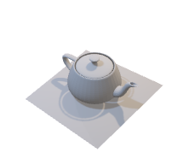INTERVIEW TEST

Develop a algorithm for splitting this model into multiple pieces:

1. Input data: teapot.obj file. This is a 3D sample with .obj format

1. Output: Split the model to 4 pieces like below

